**Asiqul Hoque**

**Section 5 Lesson 2: Using ROLLUP and CUBE Operations, and GROUPING SETS**

**1.SELECT manager_id, job_id, SUM(salary)**

**FROM employees**

**GROUP BY ROLLUP (manager_id, job_id);**

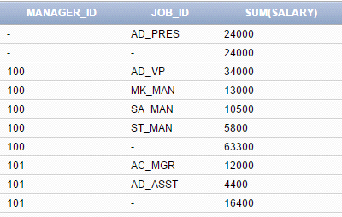

**2.SELECT manager_id, job_id, SUM(salary)**

**FROM employees**

**GROUP BY CUBE (manager_id, job_id);**

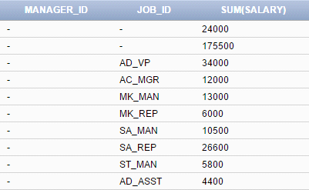

**3. SELECT department_id,manager_id,job_id, SUM(salary)**

**FROM employees**

**GROUP BY GROUPING SETS ((department_id,manager_Id,job_id),**

**(department_id,job_id), (manager_id,job_id));**

